|  |  |  |  |  |  |  |  |  |  |  |  |
| --- | --- | --- | --- | --- | --- | --- | --- | --- | --- | --- | --- |
| **Sown flower species present** | **QUADRAT** | | | | | | | | | | Enter a TICK  in this column for all sown flower species present in 5 or more quadrats |
| **1** | **2** | **3** | **4** | **5** | **6** | **7** | **8** | **9** | **10** |
| **Record all sown flower species present in each quadrat by entering X in the appropriate box** | | | | | | | | | |
| Alsike clover | X | X | X | X | X |  | X | X | X |  |  |
| Crimson clover |  |  |  |  |  |  |  |  |  |  |  |
| Red clover | X | X | X | X | X | X | X | X | X |  |  |
| Sweet clover |  |  |  |  |  |  |  |  |  |  |  |
| White clover |  |  |  |  |  |  |  |  |  |  |  |
| Sainfoin |  |  |  |  |  |  |  |  |  |  |  |
| Lucerne |  |  | X |  | X | X |  |  |  | X |  |
| Bird's-foot trefoil | X | X |  |  | X |  |  |  |  |  |  |
| Black medick | X | X | X | X |  | X |  | X | X | X |  |
| Common vetch | X |  |  |  |  |  |  |  |  |  |  |
| Black knapweed |  |  |  |  |  |  |  |  |  |  |  |
| Yarrow |  |  |  |  |  |  |  |  |  |  |  |
| Oxeye daisy |  |  |  |  |  |  |  |  |  |  |  |
| Musk mallow |  |  |  |  |  |  |  |  |  |  |  |
| Wild carrot |  |  |  |  |  |  |  |  |  |  |  |
| Red campion | X | X | X | X | X | X | X | X | X | X |  |
| White campion | X | X | X | X | X | X | X | X | X | X |  |
| Phacelia |  |  |  |  |  |  |  |  |  |  |  |
| Borage |  |  |  |  |  |  |  |  |  |  |  |
|  |  |  |  |  |  |  |  |  |  |  |  |
|  |  |  |  |  |  |  |  |  |  |  |  |
|  |  |  |  |  |  |  |  |  |  |  |  |
| **Number of species recorded in 5 or more stops** | | | | | | | | | | | **5** |

Quadrat 1

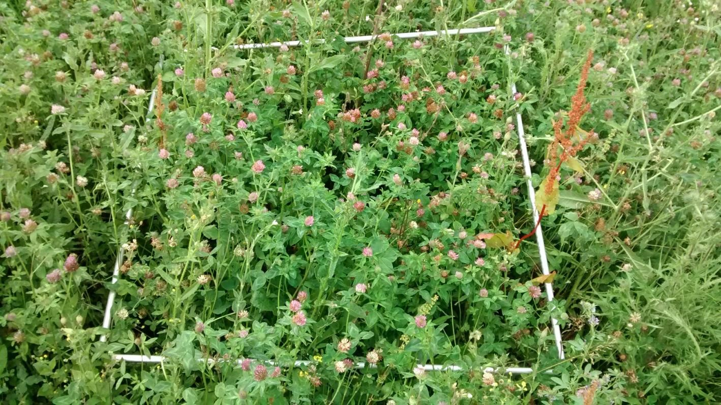

Quadrat 2

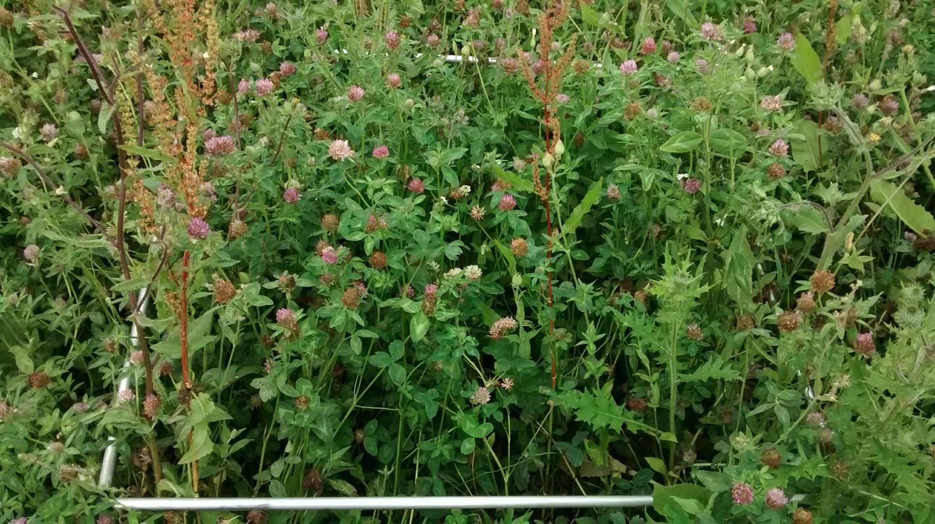

Quadrat 3

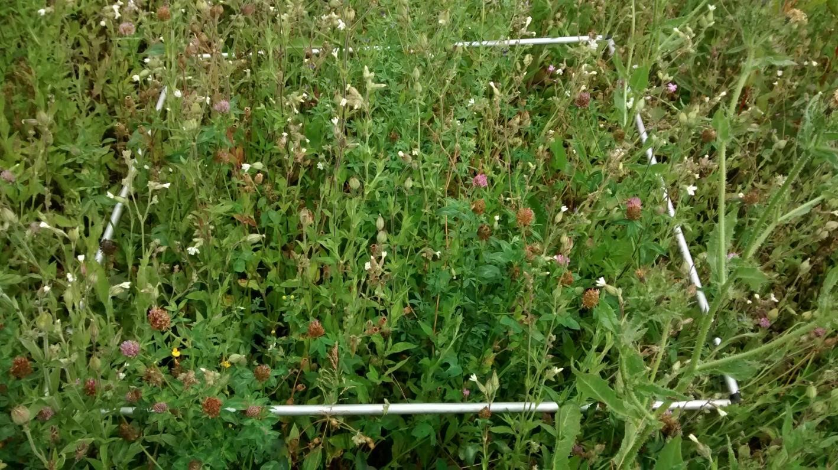

Quadrat 4

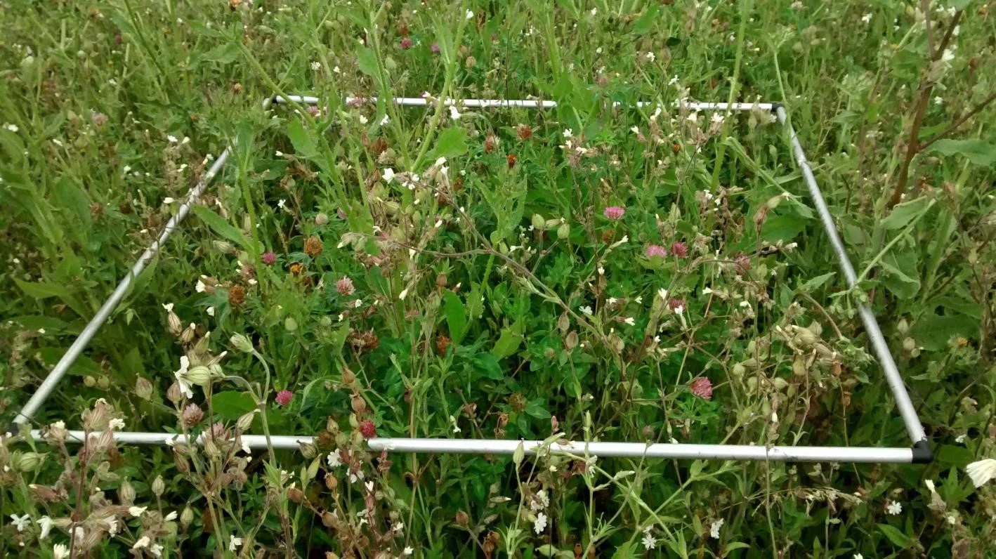

Quadrat 5

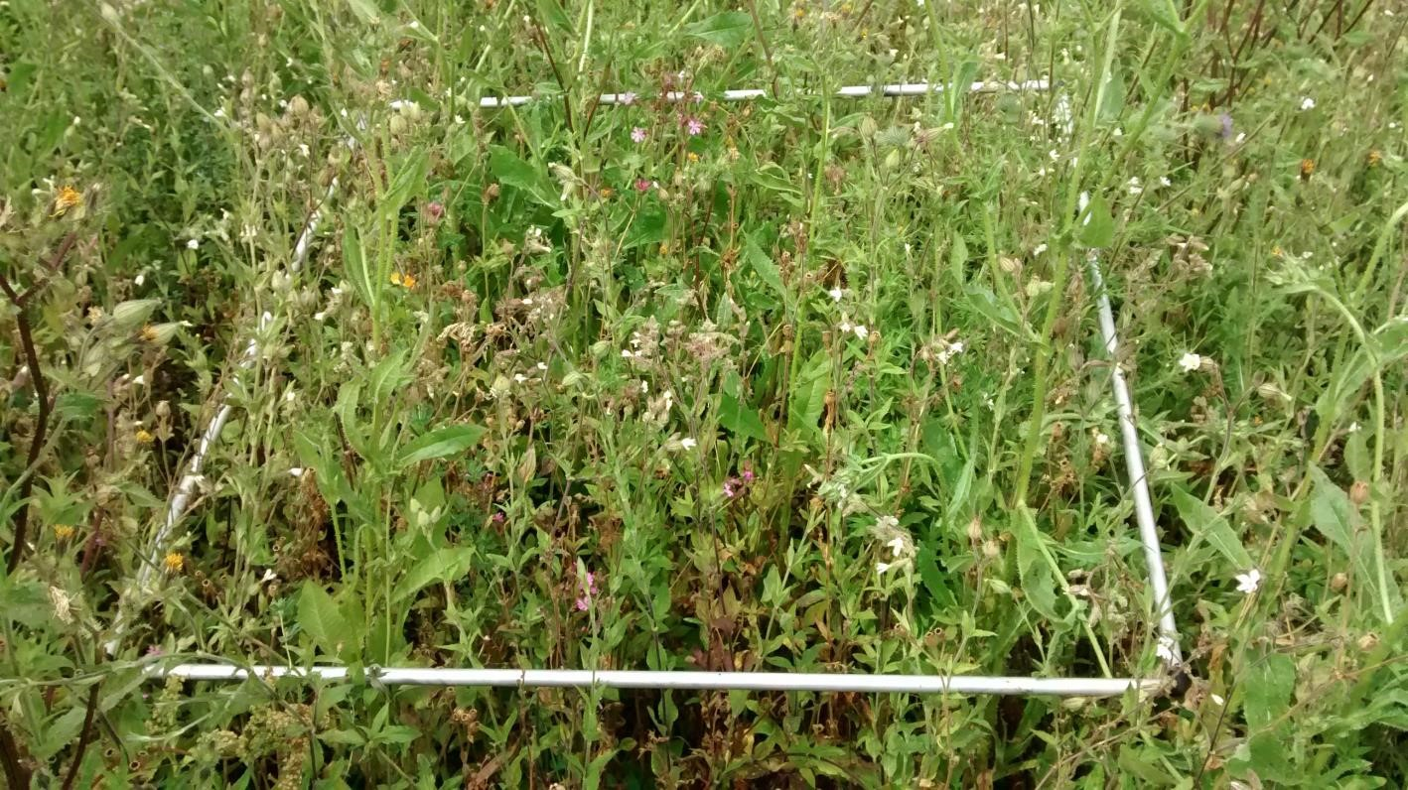

Quadrat 6

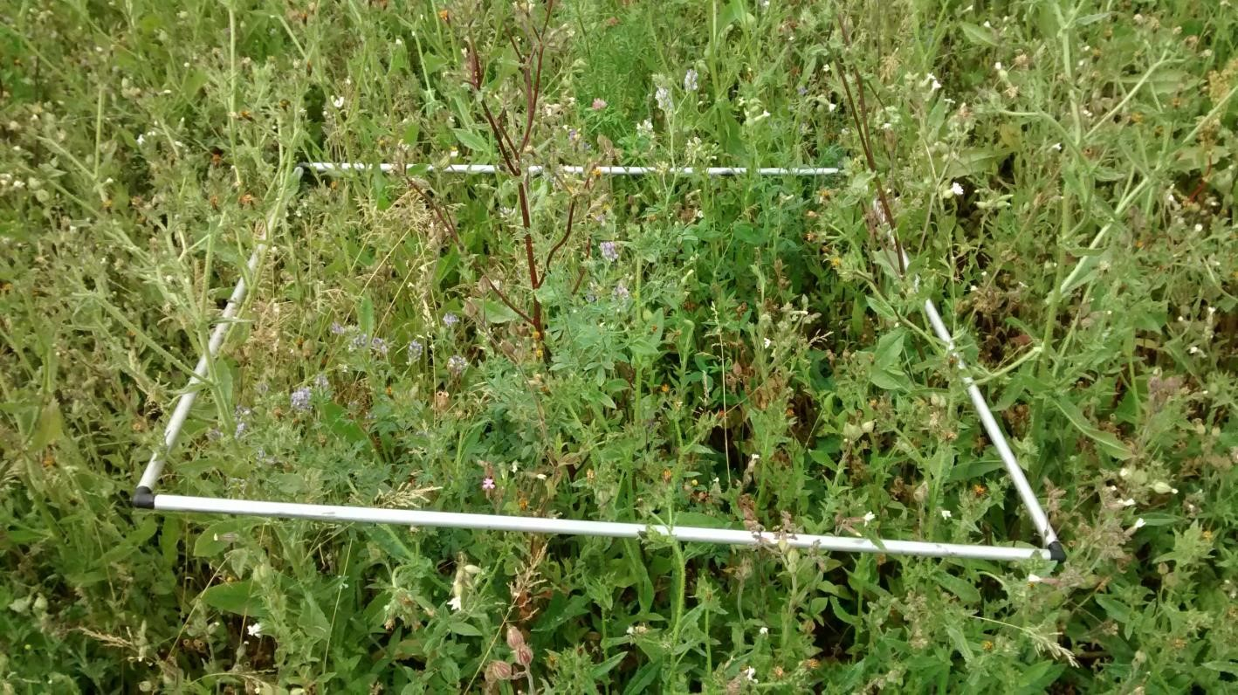

Quadrat 7

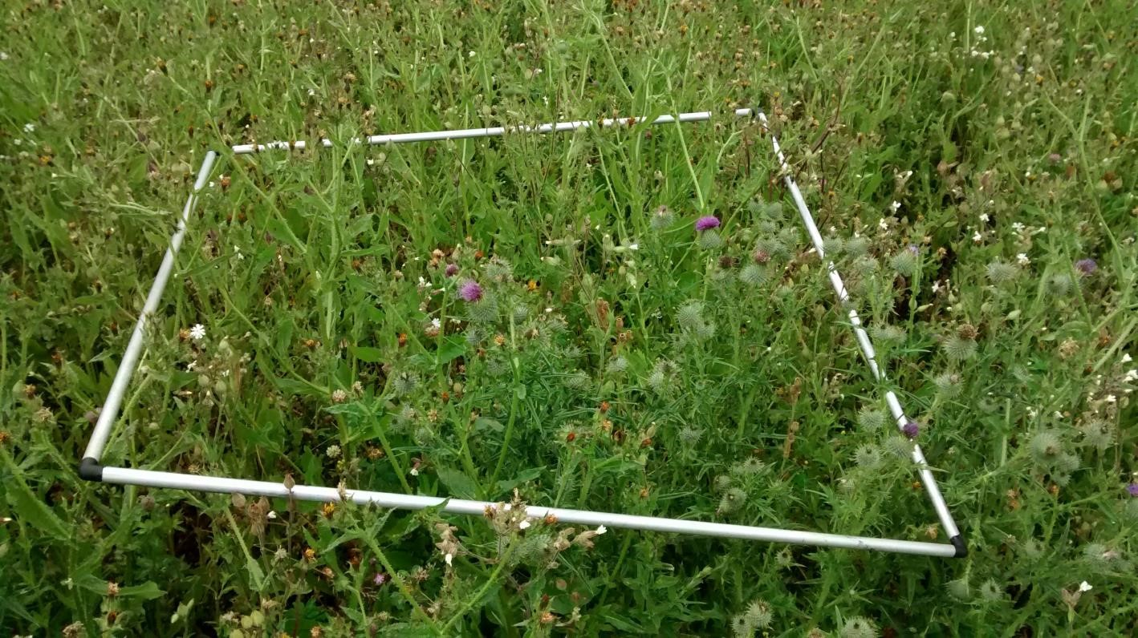

Quadrat 8

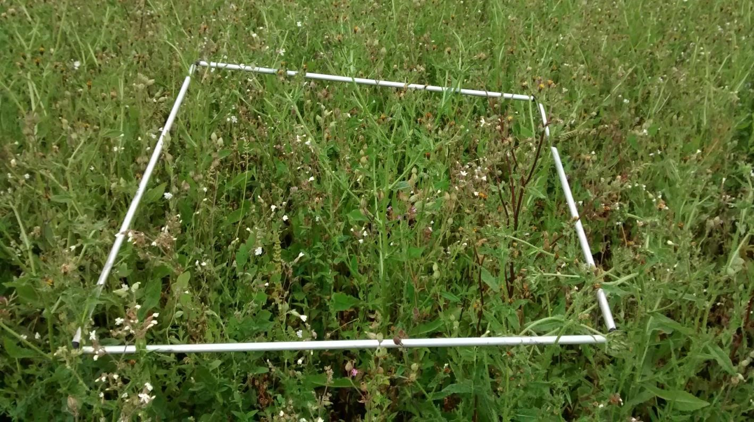

Quadrat 9

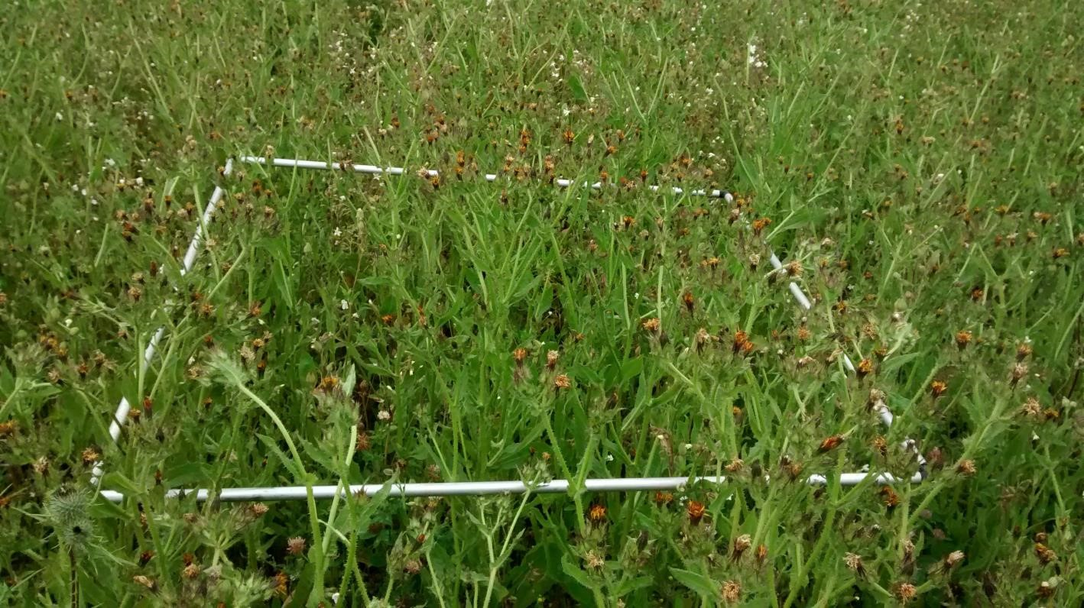

Quadrat 10

